# **12 ss Command Examples to Monitor Network Connections**

**ss command**is a tool that is used for displaying network socket related information on a Linux system. The tool displays more detailed information that the **[netstat command](https://www.tecmint.com/20-netstat-commands-for-linux-network-management/" \t "_blank)** which is used for displaying active socket connections.

In this guide, we delve in and see how the ss command can be used to display varied socket connection information in Linux.

**1. Listing all Connections**

The basic ss command without any options simply lists all the connections regardless of the state they are in.

[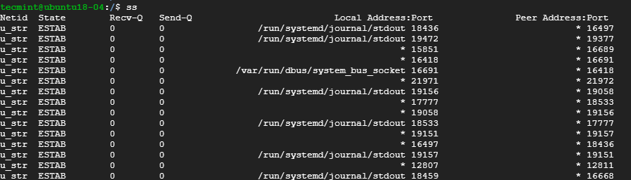](https://www.tecmint.com/wp-content/uploads/2019/09/List-All-Connections-in-Linux.png)$ ss

*List All Connections in Linux*

**2. Listing Listening and Non-listening Ports**

You can retrieve a list of both listening and non-listening ports using the **-a** option as shown below.

[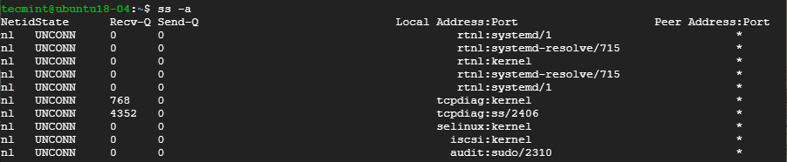](https://www.tecmint.com/wp-content/uploads/2019/09/List-All-Ports-in-Linux.png)$ ss -a

*List All Ports in Linux*

**3. Listing Listening Sockets**

To display listening sockets only, use the **-l** flag as shown.

[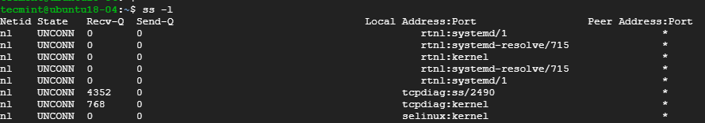](https://www.tecmint.com/wp-content/uploads/2019/09/List-Listening-Sockets-in-Linux.png)$ ss -l

*List Listening Sockets in Linux*

**4. List all TCP Connections**

To display all TCP connection, use the **-t** option as shown.

[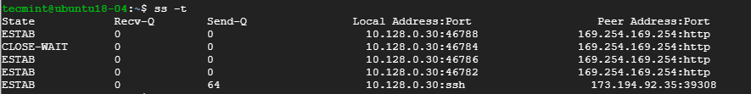](https://www.tecmint.com/wp-content/uploads/2019/09/List-TCP-Connections-in-Linux.png)$ ss -t

*List TCP Connections in Linux*

**5. List all Listening TCP Connections**

To have a view of all the listening TCP socket connection use the **-lt** combination as shown.

[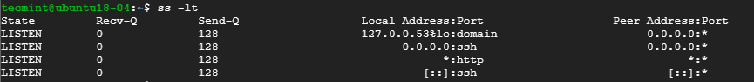](https://www.tecmint.com/wp-content/uploads/2019/09/List-Listening-TCP-Connections-in-Linux.png)$ ss -lt

*List Listening TCP Connections in Linux*

6**. List all UDP Connections**

To view all the UDP socket connections use the **-ua** option as shown.

[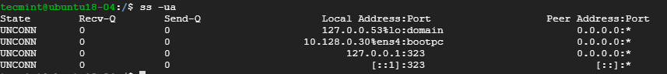](https://www.tecmint.com/wp-content/uploads/2019/09/List-UDP-Socket-Connections-in-Linux.png)$ ss -ua

*List UDP Socket Connections in Linux*

**7. List all Listening UDP Connections**

To list listening UDP connections use the **-lu** option.

[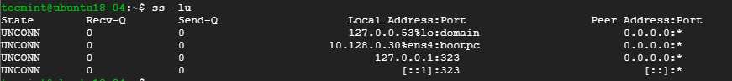](https://www.tecmint.com/wp-content/uploads/2019/09/List-Listening-UDP-Connections-in-Linux.png)$ ss -lu

*List Listening UDP Connections in Linux*

**8. Display PID (Process IDs) of Sockets**

To [display the Process IDs](https://www.tecmint.com/find-process-name-pid-number-linux/) related to socket connections, use the **-p** flag as shown.

[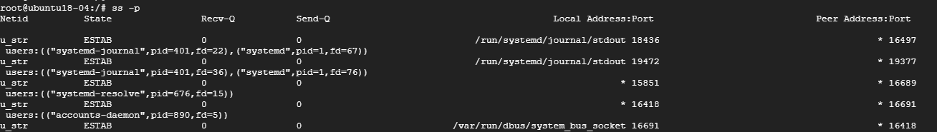](https://www.tecmint.com/wp-content/uploads/2019/09/Find-Process-ID-of-Sockets-in-Linux.png)$ ss -p

*Find Process ID of Sockets in Linux*

9**. Display Summary Statistics**

To list the summary statistics, use the **-s** option.

$ ss -s

[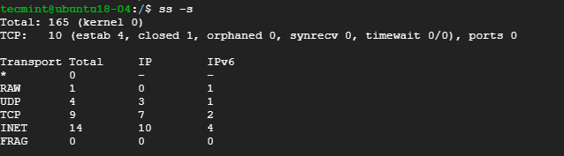](https://www.tecmint.com/wp-content/uploads/2019/09/Find-Summary-Statistics.png)*Find Summary Statistics*

**10. Display IPv4 and IPv6 Socket Connections**

If you are curious about the IPv4 socket connections use the **-4** option.

[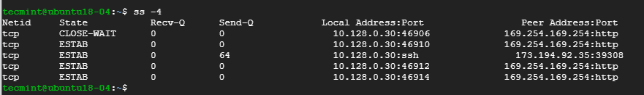](https://www.tecmint.com/wp-content/uploads/2019/09/Find-IPv4-Socket-Connections.png)$ ss -4

*Find IPv4 Socket Connections in Linux*

To display IPv6 connections, use the **-6** option.

[Find IPv6 Socket Connections in Linux](https://www.tecmint.com/wp-content/uploads/2019/09/Find-IPv6-Socket-Connections.png)$ ss -6

*Find IPv6 Socket Connections in Linux*

**11. Filter Connections by Port Number**

ss command also lets you filter socket port number or address number. For example, to display all socket connections with a destination or source port of ssh run the command.

$ ss -at '( dport = :22 or sport = :22 )'

[](https://www.tecmint.com/wp-content/uploads/2019/09/Filter-Connections-by-Port-Number.png)

*Filter Connections by Port Number*

Alternatively, you can run the command.

[](https://www.tecmint.com/wp-content/uploads/2019/09/Filter-Connections-by-Service.png)$ ss -at '( dport = :ssh or sport = :ssh )'

*Filter Connections by Service*

**12. Check Man Pages for ss Command**

To get more insights into the ss command usage, check the man pages using the command.

$ man ss

Those are some of the commonly used options that are used with ss command. The command is considered more superior to [netstat command](https://www.tecmint.com/20-netstat-commands-for-linux-network-management/" \t "_blank) and provide detailed information about network connections.

# **20 Netstat Commands for Linux Network Management**

**netstat** (**network statistics**) is a command line tool for monitoring network connections both incoming and outgoing as well as viewing routing tables, interface statistics etc.

**netstat** is available on all Unix-like Operating Systems and also available on **Windows OS** as well. It is very useful in terms of network troubleshooting and performance measurement. **netstat** is one of the most basic network service debugging tools, telling you what ports are open and whether any programs are listening on ports.

**Update**: The Linux **netstat command** is replaced by new [ss command](https://www.tecmint.com/ss-command-examples-in-linux/" \t "_blank), which is capable of displaying more information about network connections and it is much faster than the older **netstat command**.

This tool is very important and much useful for Linux network administrators as well as system administrators to monitor and troubleshoot their network-related problems and determine network traffic performance. This article shows usages of **netstat** command with their examples which may be useful in daily operation.

**1. Listing all the LISTENING Ports of TCP and UDP connections**

Listing all ports (both TCP and UDP) using **netstat** -a option.

**# netstat -a | more**

Active Internet connections (servers and established)

Proto Recv-Q Send-Q Local Address Foreign Address State

tcp 0 0 \*:sunrpc \*:\* LISTEN

tcp 0 52 192.168.0.2:ssh 192.168.0.1:egs ESTABLISHED

tcp 1 0 192.168.0.2:59292 www.gov.com:http CLOSE\_WAIT

tcp 0 0 localhost:smtp \*:\* LISTEN

tcp 0 0 \*:59482 \*:\* LISTEN

udp 0 0 \*:35036 \*:\*

udp 0 0 \*:npmp-local \*:\*

Active UNIX domain sockets (servers and established)

Proto RefCnt Flags Type State I-Node Path

unix 2 [ ACC ] STREAM LISTENING 16972 /tmp/orbit-root/linc-76b-0-6fa08790553d6

unix 2 [ ACC ] STREAM LISTENING 17149 /tmp/orbit-root/linc-794-0-7058d584166d2

unix 2 [ ACC ] STREAM LISTENING 17161 /tmp/orbit-root/linc-792-0-546fe905321cc

unix 2 [ ACC ] STREAM LISTENING 15938 /tmp/orbit-root/linc-74b-0-415135cb6aeab

**2. Listing TCP Ports connections**

Listing only **TCP** (**Transmission Control Protocol**) port connections using **netstat -at**.

**# netstat -at**

Active Internet connections (servers and established)

Proto Recv-Q Send-Q Local Address Foreign Address State

tcp 0 0 \*:ssh \*:\* LISTEN

tcp 0 0 localhost:ipp \*:\* LISTEN

tcp 0 0 localhost:smtp \*:\* LISTEN

tcp 0 52 192.168.0.2:ssh 192.168.0.1:egs ESTABLISHED

tcp 1 0 192.168.0.2:59292 www.gov.com:http CLOSE\_WAIT

**3. Listing UDP Ports connections**

Listing only **UDP** (**User Datagram Protocol**) port connections using **netstat -au**.

**# netstat -au**

Active Internet connections (servers and established)

Proto Recv-Q Send-Q Local Address Foreign Address State

udp 0 0 \*:35036 \*:\*

udp 0 0 \*:npmp-local \*:\*

udp 0 0 \*:mdns \*:\*

**4. Listing all LISTENING Connections**

Listing all active listening ports connections with **netstat -l**.

**# netstat -l**

Active Internet connections (only servers)

Proto Recv-Q Send-Q Local Address Foreign Address State

tcp 0 0 \*:sunrpc \*:\* LISTEN

tcp 0 0 \*:58642 \*:\* LISTEN

tcp 0 0 \*:ssh \*:\* LISTEN

udp 0 0 \*:35036 \*:\*

udp 0 0 \*:npmp-local \*:\*

Active UNIX domain sockets (only servers)

Proto RefCnt Flags Type State I-Node Path

unix 2 [ ACC ] STREAM LISTENING 16972 /tmp/orbit-root/linc-76b-0-6fa08790553d6

unix 2 [ ACC ] STREAM LISTENING 17149 /tmp/orbit-root/linc-794-0-7058d584166d2

unix 2 [ ACC ] STREAM LISTENING 17161 /tmp/orbit-root/linc-792-0-546fe905321cc

unix 2 [ ACC ] STREAM LISTENING 15938 /tmp/orbit-root/linc-74b-0-415135cb6aeab

**5. Listing all TCP Listening Ports**

Listing all active listening TCP ports by using option **netstat -lt**.

**# netstat -lt**

Active Internet connections (only servers)

Proto Recv-Q Send-Q Local Address Foreign Address State

tcp 0 0 \*:dctp \*:\* LISTEN

tcp 0 0 \*:mysql \*:\* LISTEN

tcp 0 0 \*:sunrpc \*:\* LISTEN

tcp 0 0 \*:munin \*:\* LISTEN

tcp 0 0 \*:ftp \*:\* LISTEN

tcp 0 0 localhost.localdomain:ipp \*:\* LISTEN

tcp 0 0 localhost.localdomain:smtp \*:\* LISTEN

tcp 0 0 \*:http \*:\* LISTEN

tcp 0 0 \*:ssh \*:\* LISTEN

tcp 0 0 \*:https \*:\* LISTEN

**6. Listing all UDP Listening Ports**

Listing all active listening UDP ports by using option **netstat -lu**.

**# netstat -lu**

Active Internet connections (only servers)

Proto Recv-Q Send-Q Local Address Foreign Address State

udp 0 0 \*:39578 \*:\*

udp 0 0 \*:meregister \*:\*

udp 0 0 \*:vpps-qua \*:\*

udp 0 0 \*:openvpn \*:\*

udp 0 0 \*:mdns \*:\*

udp 0 0 \*:sunrpc \*:\*

udp 0 0 \*:ipp \*:\*

udp 0 0 \*:60222 \*:\*

udp 0 0 \*:mdns \*:\*

**7. Listing all UNIX Listening Ports**

Listing all active UNIX listening ports using **netstat -lx**.

**# netstat -lx**

Active UNIX domain sockets (only servers)

Proto RefCnt Flags Type State I-Node Path

unix 2 [ ACC ] STREAM LISTENING 4171 @ISCSIADM\_ABSTRACT\_NAMESPACE

unix 2 [ ACC ] STREAM LISTENING 5767 /var/run/cups/cups.sock

unix 2 [ ACC ] STREAM LISTENING 7082 @/tmp/fam-root-

unix 2 [ ACC ] STREAM LISTENING 6157 /dev/gpmctl

unix 2 [ ACC ] STREAM LISTENING 6215 @/var/run/hald/dbus-IcefTIUkHm

unix 2 [ ACC ] STREAM LISTENING 6038 /tmp/.font-unix/fs7100

unix 2 [ ACC ] STREAM LISTENING 6175 /var/run/avahi-daemon/socket

unix 2 [ ACC ] STREAM LISTENING 4157 @ISCSID\_UIP\_ABSTRACT\_NAMESPACE

unix 2 [ ACC ] STREAM LISTENING 60835836 /var/lib/mysql/mysql.sock

unix 2 [ ACC ] STREAM LISTENING 4645 /var/run/audispd\_events

unix 2 [ ACC ] STREAM LISTENING 5136 /var/run/dbus/system\_bus\_socket

unix 2 [ ACC ] STREAM LISTENING 6216 @/var/run/hald/dbus-wsUBI30V2I

unix 2 [ ACC ] STREAM LISTENING 5517 /var/run/acpid.socket

unix 2 [ ACC ] STREAM LISTENING 5531 /var/run/pcscd.comm

**8. Showing Statistics by Protocol**

Displays statistics by protocol. By default, statistics are shown for the TCP, UDP, ICMP, and IP protocols. The -s parameter can be used to specify a set of protocols.

**# netstat -s**

Ip:

2461 total packets received

0 forwarded

0 incoming packets discarded

2431 incoming packets delivered

2049 requests sent out

Icmp:

0 ICMP messages received

0 input ICMP message failed.

ICMP input histogram:

1 ICMP messages sent

0 ICMP messages failed

ICMP output histogram:

destination unreachable: 1

Tcp:

159 active connections openings

1 passive connection openings

4 failed connection attempts

0 connection resets received

1 connections established

2191 segments received

1745 segments send out

24 segments retransmited

0 bad segments received.

4 resets sent

Udp:

243 packets received

1 packets to unknown port received.

0 packet receive errors

281 packets sent

**9. Showing Statistics by TCP Protocol**

Showing statistics of only TCP protocol by using option **netstat -st**.

**# netstat -st**

Tcp:

2805201 active connections openings

1597466 passive connection openings

1522484 failed connection attempts

37806 connection resets received

1 connections established

57718706 segments received

64280042 segments send out

3135688 segments retransmited

74 bad segments received.

17580 resets sent

**10. Showing Statistics by UDP Protocol**

**# netstat -su**

Udp:

1774823 packets received

901848 packets to unknown port received.

0 packet receive errors

2968722 packets sent

**11. Displaying Service name with PID**

Displaying service name with their PID number, using option **netstat -tp** will display “PID/Program Name”.

**# netstat -tp**

Active Internet connections (w/o servers)

Proto Recv-Q Send-Q Local Address Foreign Address State PID/Program name

tcp 0 0 192.168.0.2:ssh 192.168.0.1:egs ESTABLISHED 2179/sshd

tcp 1 0 192.168.0.2:59292 www.gov.com:http CLOSE\_WAIT 1939/clock-applet

**12. Displaying Promiscuous Mode**

Displaying Promiscuous mode with -ac switch, netstat print the selected information or refresh screen every five second. Default screen refresh in every second.

**# netstat -ac 5 | grep tcp**

tcp 0 0 \*:sunrpc \*:\* LISTEN

tcp 0 0 \*:58642 \*:\* LISTEN

tcp 0 0 \*:ssh \*:\* LISTEN

tcp 0 0 localhost:ipp \*:\* LISTEN

tcp 0 0 localhost:smtp \*:\* LISTEN

tcp 1 0 192.168.0.2:59447 www.gov.com:http CLOSE\_WAIT

tcp 0 52 192.168.0.2:ssh 192.168.0.1:egs ESTABLISHED

tcp 0 0 \*:sunrpc \*:\* LISTEN

tcp 0 0 \*:ssh \*:\* LISTEN

tcp 0 0 localhost:ipp \*:\* LISTEN

tcp 0 0 localhost:smtp \*:\* LISTEN

tcp 0 0 \*:59482 \*:\* LISTEN

**13. Displaying Kernel IP routing**

Display Kernel IP routing table with netstat and route command.

**# netstat -r**

Kernel IP routing table

Destination Gateway Genmask Flags MSS Window irtt Iface

192.168.0.0 \* 255.255.255.0 U 0 0 0 eth0

link-local \* 255.255.0.0 U 0 0 0 eth0

default 192.168.0.1 0.0.0.0 UG 0 0 0 eth0

**14. Showing Network Interface Transactions**

Showing network interface packet transactions including both transferring and receiving packets with MTU size.

**# netstat -i**

Kernel Interface table

Iface MTU Met RX-OK RX-ERR RX-DRP RX-OVR TX-OK TX-ERR TX-DRP TX-OVR Flg

eth0 1500 0 4459 0 0 0 4057 0 0 0 BMRU

lo 16436 0 8 0 0 0 8 0 0 0 LRU

**15. Showing Kernel Interface Table**

Showing Kernel interface table, similar to **ifconfig** command.

**# netstat -ie**

Kernel Interface table

eth0 Link encap:Ethernet HWaddr 00:0C:29:B4:DA:21

inet addr:192.168.0.2 Bcast:192.168.0.255 Mask:255.255.255.0

inet6 addr: fe80::20c:29ff:feb4:da21/64 Scope:Link

UP BROADCAST RUNNING MULTICAST MTU:1500 Metric:1

RX packets:4486 errors:0 dropped:0 overruns:0 frame:0

TX packets:4077 errors:0 dropped:0 overruns:0 carrier:0

collisions:0 txqueuelen:1000

RX bytes:2720253 (2.5 MiB) TX bytes:1161745 (1.1 MiB)

Interrupt:18 Base address:0x2000

lo Link encap:Local Loopback

inet addr:127.0.0.1 Mask:255.0.0.0

inet6 addr: ::1/128 Scope:Host

UP LOOPBACK RUNNING MTU:16436 Metric:1

RX packets:8 errors:0 dropped:0 overruns:0 frame:0

TX packets:8 errors:0 dropped:0 overruns:0 carrier:0

collisions:0 txqueuelen:0

RX bytes:480 (480.0 b) TX bytes:480 (480.0 b)

**16. Displaying IPv4 and IPv6 Information**

Displays multicast group membership information for both IPv4 and IPv6.

**# netstat -g**

IPv6/IPv4 Group Memberships

Interface RefCnt Group

--------------- ------ ---------------------

lo 1 all-systems.mcast.net

eth0 1 224.0.0.251

eth0 1 all-systems.mcast.net

lo 1 ff02::1

eth0 1 ff02::202

eth0 1 ff02::1:ffb4:da21

eth0 1 ff02::1

**17. Print Netstat Information Continuously**

To get netstat information every few second, then use the following command, it will print netstat information continuously, say every few seconds.

**# netstat -c**

Active Internet connections (w/o servers)

Proto Recv-Q Send-Q Local Address Foreign Address State

tcp 0 0 tecmint.com:http sg2nlhg007.shr.prod.s:36944 TIME\_WAIT

tcp 0 0 tecmint.com:http sg2nlhg010.shr.prod.s:42110 TIME\_WAIT

tcp 0 132 tecmint.com:ssh 115.113.134.3.static-:64662 ESTABLISHED

tcp 0 0 tecmint.com:http crawl-66-249-71-240.g:41166 TIME\_WAIT

tcp 0 0 localhost.localdomain:54823 localhost.localdomain:smtp TIME\_WAIT

tcp 0 0 localhost.localdomain:54822 localhost.localdomain:smtp TIME\_WAIT

tcp 0 0 tecmint.com:http sg2nlhg010.shr.prod.s:42091 TIME\_WAIT

tcp 0 0 tecmint.com:http sg2nlhg007.shr.prod.s:36998 TIME\_WAIT

**18. Finding non supportive Address**

Finding un-configured address families with some useful information.

**# netstat --verbose**

netstat: no support for `AF IPX' on this system.

netstat: no support for `AF AX25' on this system.

netstat: no support for `AF X25' on this system.

netstat: no support for `AF NETROM' on this system.

**19. Finding Listening Programs**

Find out how many listening programs running on a port.

**# netstat -ap | grep http**

tcp 0 0 \*:http \*:\* LISTEN 9056/httpd

tcp 0 0 \*:https \*:\* LISTEN 9056/httpd

tcp 0 0 tecmint.com:http sg2nlhg008.shr.prod.s:35248 TIME\_WAIT -

tcp 0 0 tecmint.com:http sg2nlhg007.shr.prod.s:57783 TIME\_WAIT -

tcp 0 0 tecmint.com:http sg2nlhg007.shr.prod.s:57769 TIME\_WAIT -

tcp 0 0 tecmint.com:http sg2nlhg008.shr.prod.s:35270 TIME\_WAIT -

tcp 0 0 tecmint.com:http sg2nlhg009.shr.prod.s:41637 TIME\_WAIT -

tcp 0 0 tecmint.com:http sg2nlhg009.shr.prod.s:41614 TIME\_WAIT -

unix 2 [ ] STREAM CONNECTED 88586726 10394/httpd

**20. Displaying RAW Network Statistics**

**# netstat --statistics --raw**

Ip:

62175683 total packets received

52970 with invalid addresses

0 forwarded

Icmp:

875519 ICMP messages received

destination unreachable: 901671

echo request: 8

echo replies: 16253

IcmpMsg:

InType0: 83

IpExt:

InMcastPkts: 117

That’s it, if you are looking for more information and options about **netstat** command, refer **netstat** manual docs or use **man netstat** command to know all the information. If we’ve missed anything in the list, please inform us using our comment section below. So, we could keep updating this list based on your comments.

Sharing is Caring...